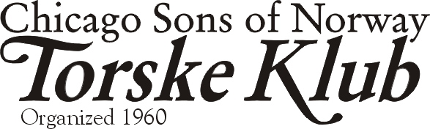
The Chicago Fire for Father/Son/Daughter Day
April 10, 2004

Dear Torske Klub Member and friends of the Torske Klub,

Our annual Father/Son/daughter day will be held at the April Torske Klub meeting on April 10, 2004 at the Des Plaines Elks Club, 495 Lee Street, Des Plaines, IL (847-824-1556). Cocktail hour begins at Noon; Dinner starts promptly at 1:00 P.M. when, according to our tradition, our BOSS, Robert Alsaker, rings the bell.

We are delighted to have a representative of the Chicago Fire Soccer Team as our speaker. At the time of this mailing, that person is not identified, but we believe it will be an interesting day, especially for any young soccer players who would be interested in attending. Our Torskemaster for the day is our gifted and clever member, Kurt Gustafson, who has helped arrange the day.

Make Your April Dinner Reservation before TUESDAY NOON, April 6, 2004…
…to insure that you receive a fresh fish dinner. Late reservations have the risk of being served the fish of the day.

Call 630-443-6839 at any time day or night to leave a reservation. As usual, please leave your MEMBERSHIP NUMBER, NAME, and the TOTAL number of people in your party. The same information is required when you reserve for other members. This reservation phone is usually unattended since it is an answering system only. It will ring 4 times before answering. Optionally, call my office at 847-781-6820 during weekday business hours. If I am not there, leave a message at either of the phones and I’ll get back to you. I’ll be traveling for business during the reservation period.

For those with email, feel free to send me a note to secretary@torskeklub.org with the same information and the message title “Torske Klub Reservation”. I will reply to that with a confirmation of receipt. If you get no response, please write again, we have discovered some transmission errors. As always, if you wish to be included or excluded from this list, please contact me.

We have April dinner reservations from 3, 13C, 22, 43A, 47, 54, 55, 64A, 73C, 78, 98 (2), 114, 126. Gentlemen, remember that ladies day is in May. This month, however, your daughters may attend. The first registered guest this month is a young man of 4 who will be attending his first Torske dinner with his dad and bestemor.

March Torske Klub Meeting
Our speaker for the March Dinner was our own Ken Nordan, who discussed his Norwegian heritage, his background and the significant of knowledge management within corporations. Good Job, Ken. We also thank the competent Bill Schreidrich for his taking the helm as Torskemaster.

News from the Boss
This year Torske Klub will be participating and marching in the Syttende Mai parade sponsored by the Norwegian National League in Park Ridge. Our good member, Hank Solberg, has offered the use of his 1956 Pontiac for us to march behind. We will have a banner and Hank's Pontiac will be identified with Torske Klub signs. The Boss wants as many members as we can gather to make a strong showing in this year's parade so mark the date...Sunday May 16th.

The boss can be also contacted by email at boss@torskeklub.org.

Birthdays in April
Let’s try something new. We know your birthday months, but we don’t always see you on your birthday. So let’s recognize our members with a birthday this month of April: Dick Fjeldheim (our board member and raffle chairman), David Hardy, Ivar Ranvik and Steinar Stein. We skål to you this month.
I love Torske!
Klub News for April
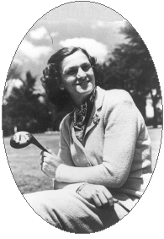
We have a lot of news this month. First, the board of directors have considered a first for the Torske Klub: an all female meeting. In addition to the special events we host every year, such as the father/son/daughter and the ladies day in May, the men of the Torske Klub will step aside to allow the women of their lives the opportunity to meet and enjoy the fellowship. For this event, no men will be allowed. The potential speakers being considered for this initial event have already been contacted and are being considered as this letter goes out. They include the late and controversial Cincinnati Reds owner Marge Schott, the talented late and great athlete Mildred “Babe” Didrickson (see photo), or the late Norwegian author Sigrid Undset, who wrote the historical novel “Kristin Lavransdatter” for which she received the 1928 Nobel Prize. This event will be held sometime during our usual June, July or August meetings, to be determined. Above all, the men of the klub get a Saturday off!

For this meeting and for consideration afterward, the Torske Klub will replace our usual Linie Aquavit with “Linie Lite”, a new product that offers low carbs, half the calories, half the alcohol, half the price, and half the taste! The recent development of this product was quite by accident. You may recall that the original Linie Aquavit is shipped to the southern hemisphere in barrels on ships from Norway. It was discovered that crew frequently helped themselves to the batch, covering their tracks by replacing the pilfered drink with water. As Norwegians will make do with what they have, the returned cargo was re-branded to reflect the new product. “If this works out, we can drink twice as much!” one Torske Klub member is quoted to say.

By the way, you should be receiving this letter on or around April 1st, which is traditionally celebrated as April Fools Day. I hope we have celebrated appropriately in the previous two paragraphs.

Remember to Bring a Guest next time
- Any male guest to the Torske Klub this season, who is 21 - 50 years old, will have his first dinner paid for by the Klub if he joins the Torske Klub.

Beste Hilsen,
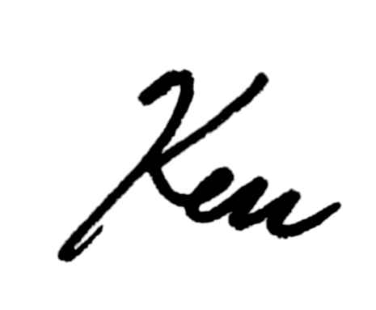
Ken Larson, Secretary

