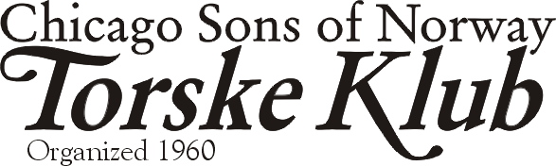
Christmas Meeting
December 13, 2003

Dear Torske Klub Member,

Our Christmas Party Torske Klub meeting will be held on December 13, 2003 at the Des Plaines Elks Club, 495 Lee Street, Des Plaines, IL (847-824-1556). Cocktail hour begins at Noon; Dinner starts promptly at 1:00 P.M. when, according to our tradition, our BOSS, Robert Alsaker, rings the bell.
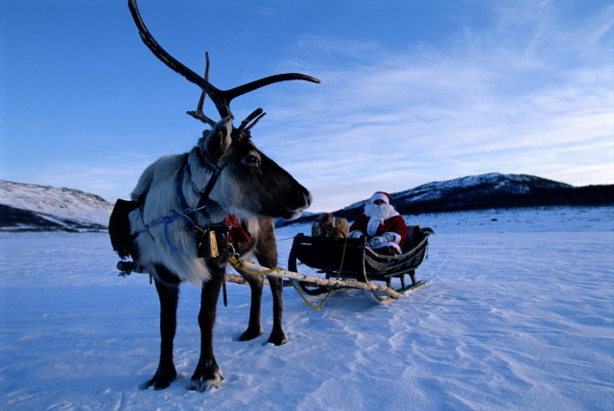
Is this why Don Hogansen goes to Norway in December?
We forego a speaker in December, favoring out good member and tenor, Rev. David Langseth instead to lead us in a round of Christmas Carols.

Be sure to come early, we have ordered a smoke salmon, capers and garnish for an appetizer during cocktail hour. Also, if you recall last month, Carl Eglund donated a red Norwegian Military Helmet, decorated with various Norwegian and Torske Klub logos. It will be in our cache of prizes this month.

The boss, Rob Alsaker, will be our Torskemaster for this month.

…Make Your December Dinner Reservation before TUESDAY NOON, December 4, 2003
…to insure that you receive a fresh fish dinner. If you’re reading this letter, call right now! By consensus of the Torske Klub board, I will note the reservations of the late callers. If we can serve you a fresh fish dinner, all is well. If there is not enough to distribute, the late reservations will be served the fresh frozen fillets (which are not too bad anyway). THANK YOU to all for all the timely calls last month.

Call 630-443-6839 at any time day or night to leave a reservation. As usual, please leave your MEMBERSHIP NUMBER, NAME, and the TOTAL number of people in your party. The same information is required when you reserve for other members. As we did last year, this reservation phone is unattended since it is an answering system only. It will ring 4 times before answering. If you need to speak to me urgently, please call my office at 847-781-6820 during weekday business hours. If I am not there, leave a message at either phone and I’ll get back to you. I am frequently out of town during the reservation period, so please be patient with my response.

For those with email, feel free to send me a note to secretary@torskeklub.org with the same information and the message title “Torske Klub Reservation”. I will reply to that with a confirmation of receipt. I believe that I have an internet email account for everyone that wants an email notice.

I have December dinner reservations from 3, 13C, 22, 43A, 47, 51, 55, 64A, 73C, 85, 98, 114, 126.

Speaking of the Internet…
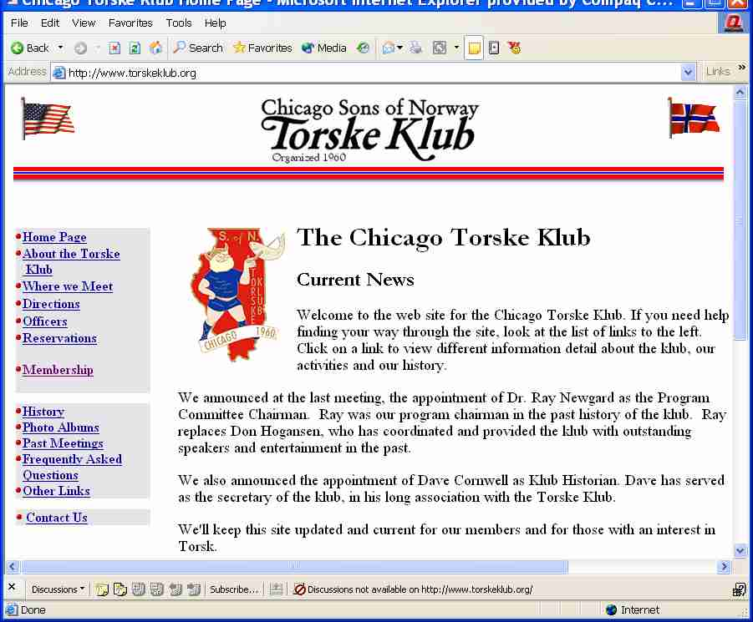
The board of directors elected to establish an internet web site for our Torske Klub! It is found at http://www.torskeklub.org for of you with internet access. Why have a web site? Three primary reasons:
- It provides another means to communicate with our members. Instead of filling their mailbox with this letter, we will provide a copy on the website to view when you want to.
- It acts as an international billboard of our organization to the world.
- It provides a historical context to our klub. We are over 40 years old. Our history is intermingled with that of the Norwegian-American Colony. It will be documented here.
All this said, we will continue to send this letter and support the way that the klub has operated in the past. All of you without internet service can continue to call the phone reservations with your rotary phone and drive to the meetings in your Edsel…sorry, I work in the computer industry and I couldn’t resist that…

As a free option to our internet service, we have 99 email accounts available. Rob (boss@torskeknub.org) and I have each taken one for Torske Klub correspondence. Other officers OR members may also have one, if you are so inclined. Note that this is NOT a connection to the internet, just an email account.

This is work in progress. By definition, a web site is never completed; it changes and evolves. If you have ideas or comments, please contact us.

New Members!
We were honored to have William Kronborg attend the dinner last month and join us as a new member. He hails from Park Ridge. We also welcome Ronald Kotz of Northbrook. Welcome both!

News from the Boss
As announced in the last meeting, we have two announcements:
- Dr. Ray Newgard has graciously agreed to take the position of Program Chairman starting January 2004. Ray is on the board and as one of our last charter members, he has served in this capacity and as board member for years.
- Ray takes over for Don Hogansen, who I’m sure you’ll agree has delivered some magnificent programs through the last years as program chairman. Don has taken on the position of president of the Norwegian-American Chamber of Commerce in the Chicago area and thus asked to step down as program chairman. Don continued his role as Assistant Boss and board member in the klub. Tusen Takk, Don.

- Dave Cornwell, our dedicated secretary emeritus, has a large cache of records, photos and klub history. He has been asked, and has accepted a new position of klub Historian. We have reserved a space on the web site for his contributions in this area in the future. (look for the “Vikings at Work” symbol on the website)
- Dick Fjeldheim has served as our raffle chairman for years, quietly and dedicated in his pursuit of the perfect raffle prize. He has delivered on that goal consistently and frequently out of his own pocket (as has Don Hogansen, by the way). We are greatly indebted to their work behind the scenes. These successful raffles have provided MANY extras to the klub that we could not have afforded otherwise. We formally acknowledge Dick in this role.
Thanks again to all the klub supporters and officers, not specifically named here, but we appreciate your ongoing work.

November Torske Klub Meeting
Our fascinating speaker in November was our own Rob Alsaker. Rob delivered his unique insight, including blueprints and history, of the Auditorium Theatre in Chicago. He managed that organization for years. Once again, we have dipped into our own klub to find one of the most interesting topics and deliveries that we could have found. By the way, there is more about the Auditorium Theatre at http://www.auditoriumtheatre.org on the internet.

Thanks to Garry Grube for his fine job as Torskemaster. Thanks also to Robert Frost for taking the duties as Wine Committee Chairman in Garry’s place.

Membership and Dues
Remember to send your $35 dues to me or submit them at the dinner. Membership cards will be issued in the January mailing. A majority of the dues have been received.

Remember to Bring a Guest next time
- Any male guest to the Torske Klub this season, who is 21 - 50 years old, will have his first dinner paid for by the Klub if he joins the Torske Klub.

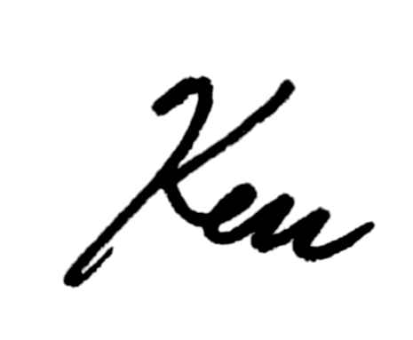
Beste Hilsen,
Ken Larson

